NAME: VEDIKA KULKARNI
SECTION: 6
EXPERIMENT : 1

Code:

#include <stdio.h>
#include <stdlib.h>
#include <unistd.h>
#include <sys/wait.h>

int main()
{
char cmd[100];

printf("Enter Linux command: ");
scanf("%s", cmd);

pid_t pid = fork();

if (pid == 0)
{
printf("Child PID : %d\n", getpid());
execlp(cmd, cmd, NULL);
perror("Execution Failed");
}
else if (pid > 0)
{
printf("Parent PID : %d\n", getpid());
wait(NULL);
printf("Child process completed.\n");
}
else
{
printf("Fork Failed\n");
}

return 0;
}

RESULT:
Using the following commands:

1. uname
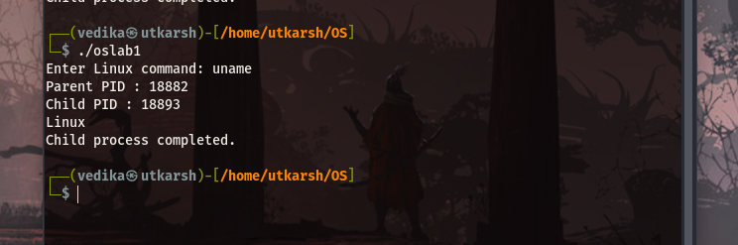

2. lscpu:

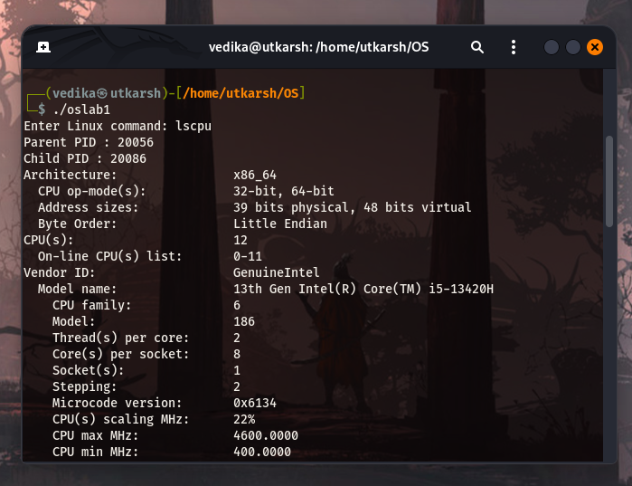

3. lsblk

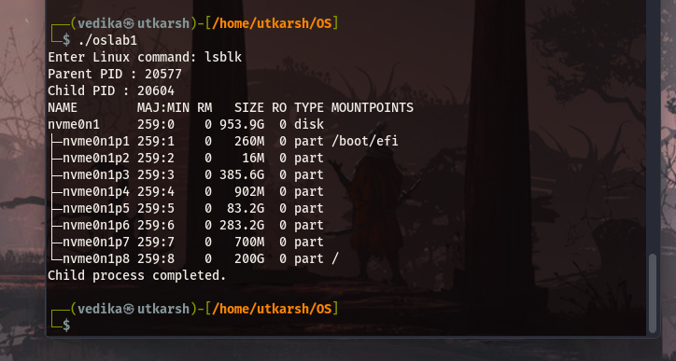
4. ps

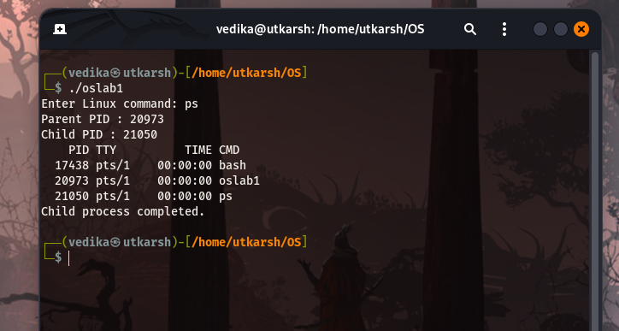

3. top
